Universal Shoe Rack Support
  - Installation: 2 ways to install the Shoe Rack Support

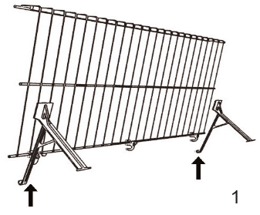
The first way to install the Shoe Rack Support is while the shelf is on the wall
- Install an inverted shelf to back wall and tilt the shelf all the way up
- Clip the Shoe Rack Support over the back rod as pictured in 1
  - The hook is durable enough to be able to be clipped onto the shelf at almost any angle
  - After installation the Shoe Rack Support hangs from the shelf and rests on the wall
- Simply tilt the shelf down onto the Shoe Brackets.
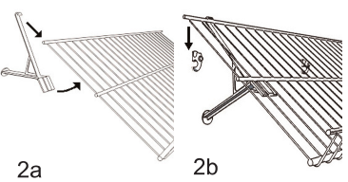
- Easiest and Quickest way to install the shelf

The second way to install the Shoe Rack Support is while the shelf is off of the wall.
- Clip the Shoe Bracket onto the inverted shelf while it is off of the wall as pictured in 2a.
  - After installation the Shoe Rack Support hangs from the shelf and rests on the wall
- Take the shelf and install it to the back wall by snapping the shelf down into the Versa-Clips.

The Shoe Rack Support has been designed so that it will not turn under the shelf.

The wide plate that the shelf sits on keeps our shelf supported for either 12” or 16” deep shelving Even if it does not sit on a shelf rod the crosswires are more than strong enough to support the weight.

